RoadSafe: Phase 2, Modelling with Classes
Industry Project, Phase 2 | Software Development | October 2026

1. Class Diagram
The class diagram shows the main classes of RoadSafe, their attributes and operations, and how they relate. A User owns many Assessments. Each Assessment refers to exactly one value from each lookup class (road type, lighting, weather, time of day) and to one risk level. RiskModel produces the score and its explanation, and AuthService looks after passwords and login tokens.
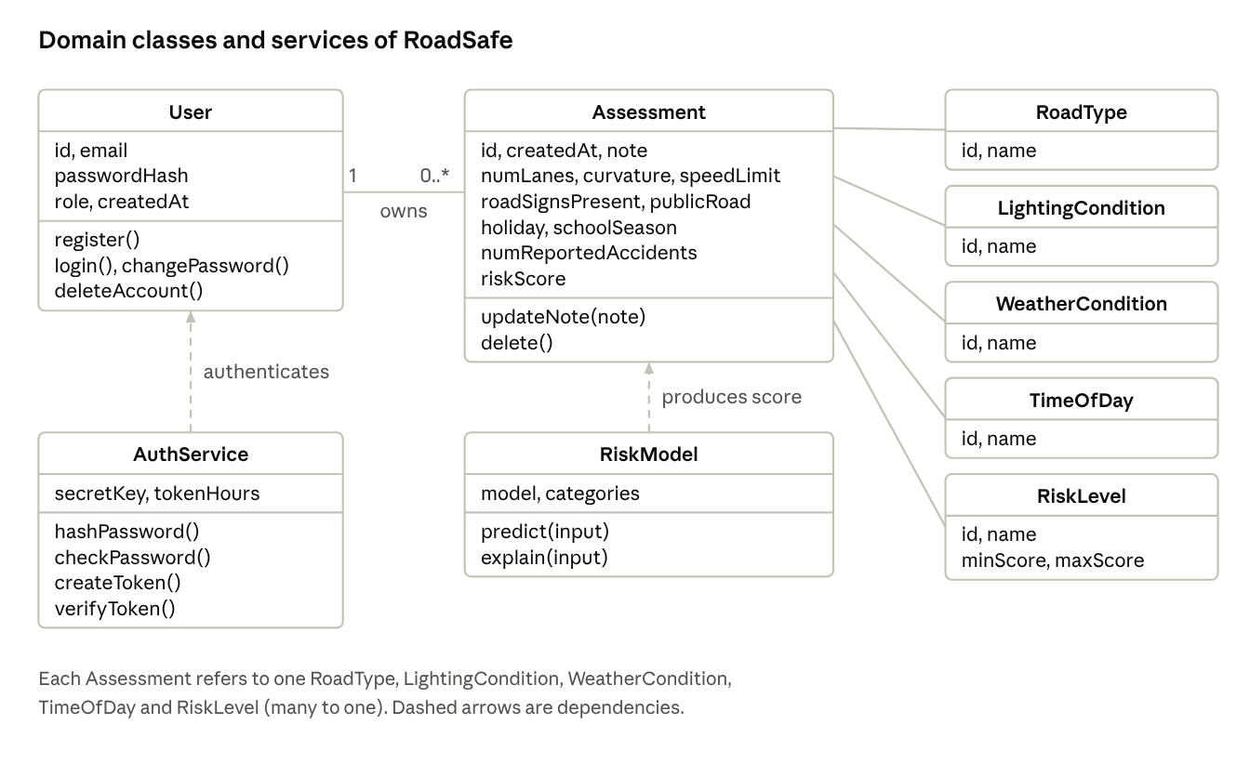
class diagram
Class | Responsibility
User | Holds an account (email, password hash, role). Can register, log in, change its password and delete itself
Assessment | One saved risk assessment: the 12 road inputs, the score, a note and the time. The owner can edit the note or delete it
RoadType, LightingCondition, WeatherCondition, TimeOfDay | Lookup classes that keep each allowed value once, so assessments store a reference and not repeated text
RiskLevel | Names the score bands: Low, Moderate, High and Severe, with their minimum and maximum scores
RiskModel | Loads the trained gradient boosting model, predicts the risk score and explains the main factors
AuthService | Hashes and checks passwords with bcrypt and creates and verifies signed login tokens (JWT)

2. Sequence Diagram
The sequence diagram follows use case UC1, predict accident risk, for a logged-in user. It starts when the user selects Predict and ends when the result and the refreshed history are shown. When the user is not logged in, the system skips the database steps and the result says it was not saved.
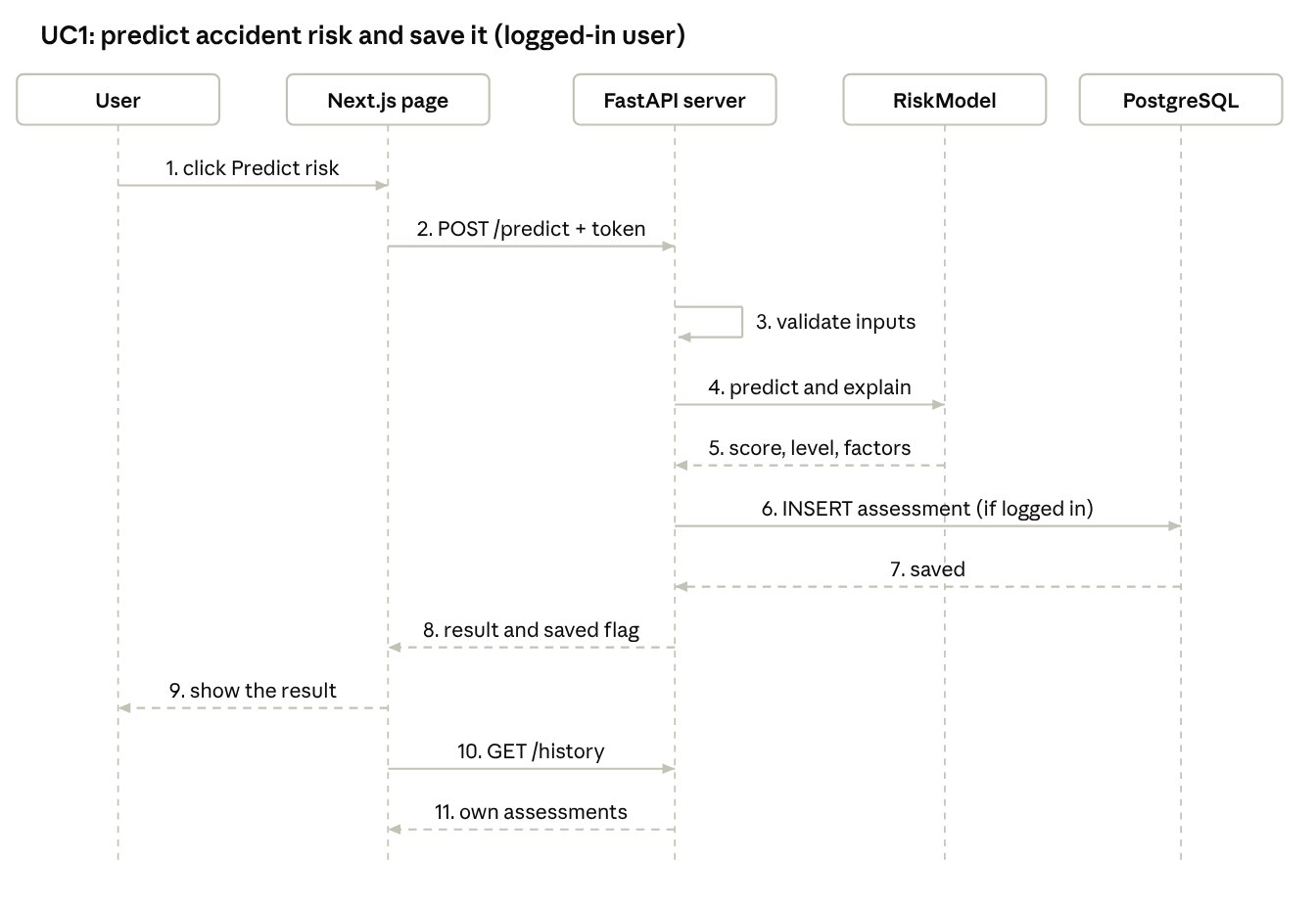
sequence diagram

3. State Diagrams
Two state diagrams describe how the system behaves over time. The first shows a user's session, from anonymous visitor to logged-in user and back, or to a deleted account. The second shows the life of a saved assessment, which is created when a logged-in user predicts, can have its note updated any number of times, and ends when it is deleted.
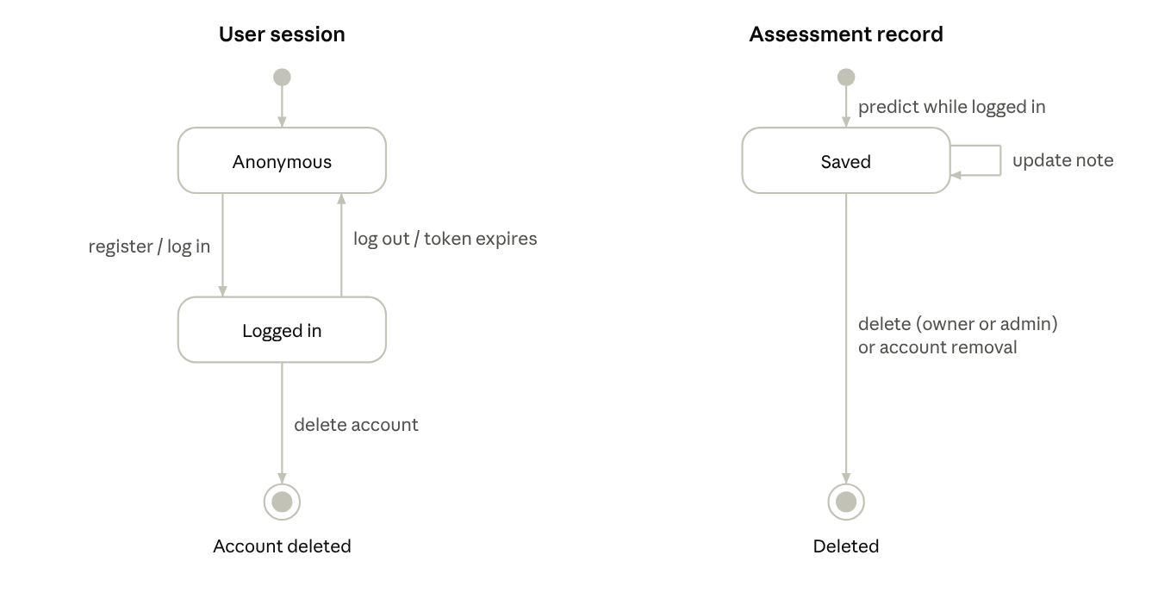
state diagrams

4. Activity Diagram
The activity diagram shows the flow of the predict activity across two swimlanes, the user and the system. After the inputs are validated, the risk score and the factor effects are calculated at the same time (a fork and a join). Logged-in users also have the assessment saved.
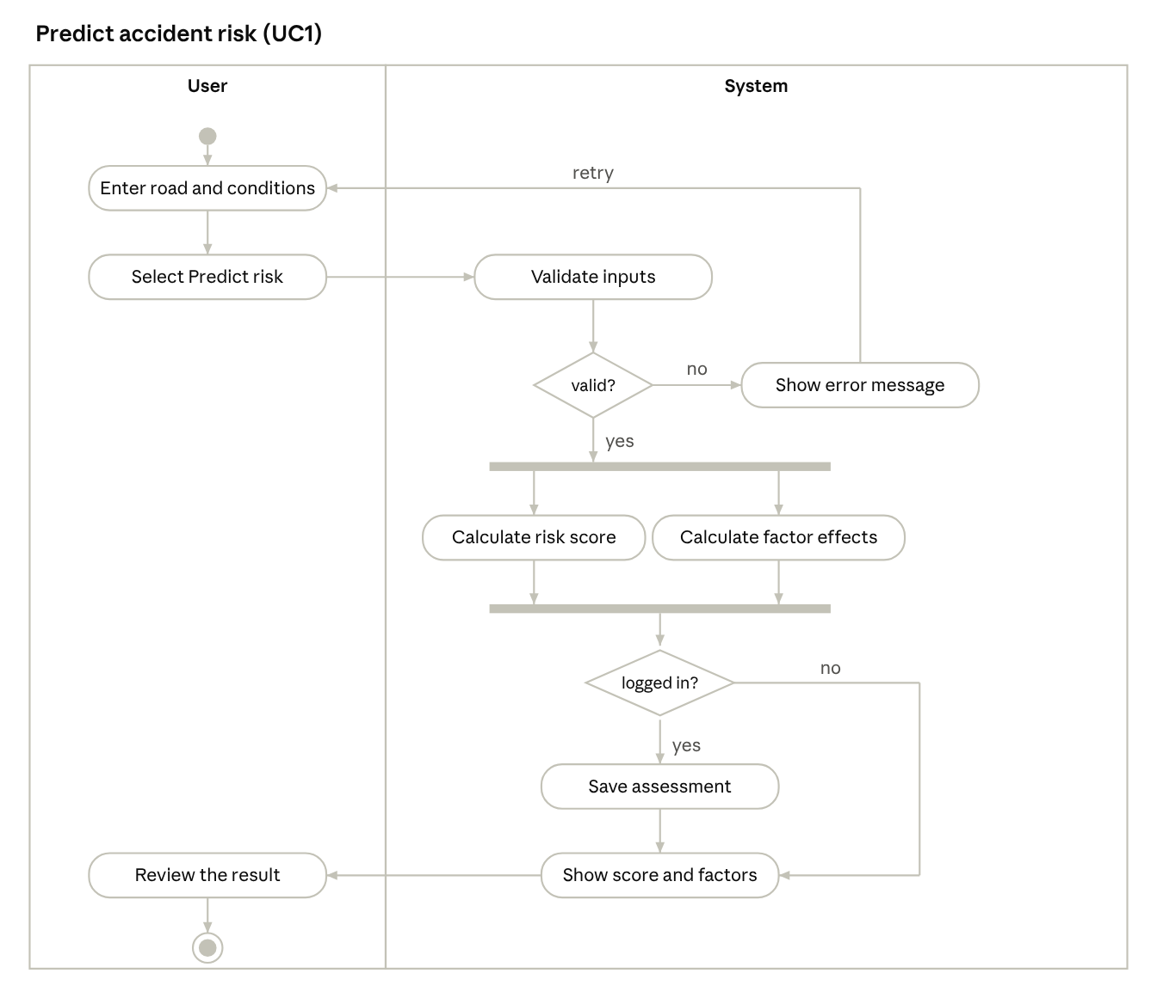
activity diagram

5. Component Diagram
The component diagram shows the three tiers and the parts inside each. The browser runs the Next.js application. The FastAPI server contains the route modules, the risk model, security and the database access layer. PostgreSQL stores the users, assessments and lookup tables. The tiers talk over HTTPS with JSON, and over SQL.
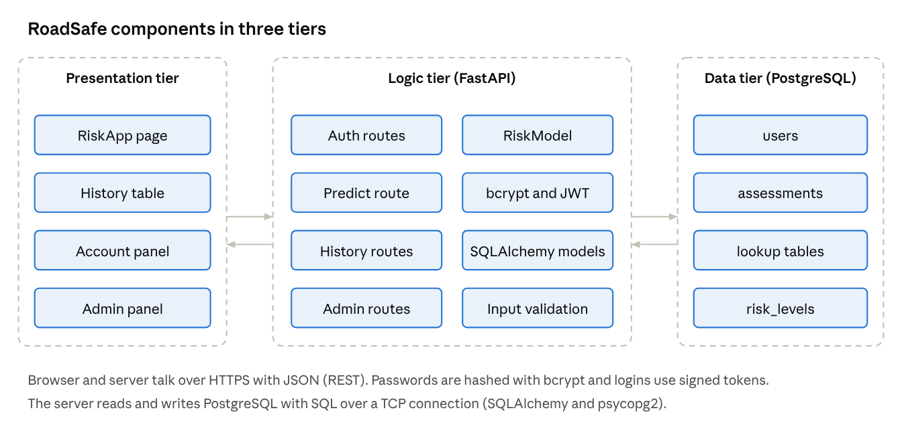
component diagram

6. Deployment Diagram
The deployment diagram shows where the software runs. In production, Render hosts the frontend and backend as Docker services and a PostgreSQL database in Frankfurt, and it redeploys automatically when new code is pushed to GitHub. On the developer's laptop, Docker Compose runs the same three parts as containers, with a volume that keeps the database files.
